HYDE PARK BATTERY ENERGY STORAGE SYSTEM | PROJECT 21334 | 10 MW / 20 MWh
One project, seven cost boundaries
The battery supply contract is $12.1 million. The project that puts it into service is $57.2 million. Both figures are correct; they describe different scopes. The table shows the same project at each boundary where a cost can be quoted, so that any published benchmark can be set beside the row that shares its definition.
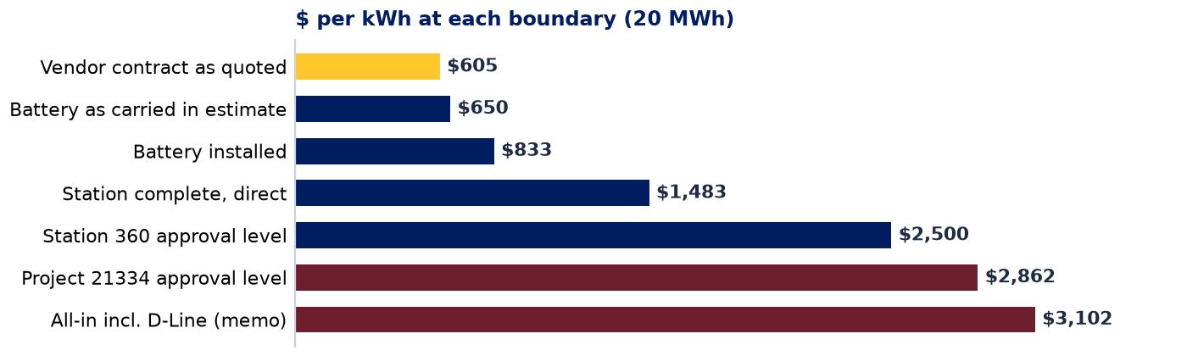
Boundary | Total | $/kW | $/kWh | x | What this boundary adds
1 Vendor contract as quoted | $12,106,850 | $1,211 | $605 | 1.0x | Twelve LFP units, PCS, BMS, fire protection, 10-yr warranty, spares, support, supervision. Fixed price (Nomad, 10 Mar 2026).
2 Battery as carried in estimate | $12,991,104 | $1,299 | $650 | 1.1x | Adds $1.13M escalation on the unpaid balance.
3 Battery installed | $16,657,252 | $1,666 | $833 | 1.4x | Adds installation labor, foundation pads, fire suppression, four 3 MVA step-up transformers, EMS, auxiliary power.
4 Station complete, direct | $29,665,294 | $2,967 | $1,483 | 2.5x | Adds the 13.8 kV switching station (four breaker skids, metering, cable, duct bank, ground grid), landfill site development, testing, engineering, Article 80 siting, outreach, project management, taxes.
5 Station 360 approval level | $49,994,200 | $4,999 | $2,500 | 4.1x | Adds risk register, contingency, corporate indirects, AFUDC.
6 Project 21334 approval level | $57,247,300 | $5,725 | $2,862 | 4.7x | Adds Station 496 feeder protection: 20 relays, transfer trip, RTU, testing ($7.25M).
7 All-in incl. D-Line (memo) | $62,040,300 | $6,204 | $3,102 | 5.1x | Adds the 5,465 ft circuit extension under project 24211 ($4.79M, Feb 2024 conceptual, not re-based).

Where the other 79 percent sits (loaded, i.e. with risk, contingency, indirects and AFUDC spread across Station 360 layers): station and feeder interconnection facilities $18.3M (32%); battery installation and balance of plant $6.2M (11%); engineering, siting, outreach, project management, testing and taxes $10.9M (19%); battery supply contract $21.9M (38%).
Reading a benchmark against this table. A published $/kWh figure belongs beside the boundary that shares its scope. Pack and cell prices (BloombergNEF, $70 to $108/kWh in 2025) stop at the factory door and compare to nothing here. Turnkey system prices (BloombergNEF US $219/kWh, 2025; Anza distribution-scale $203/kWh, Q1 2026) stop at the fence and compare to boundary 3, after adjusting a four-hour, 100 MW reference to two hours and 10 MW. All-in developer benchmarks (NREL $334/kWh, EIA and Sargent & Lundy $436/kWh, LBNL $458/kWh, all four-hour, 60 to 150 MW) compare to boundary 4, less a developer's margin. Disclosed utility-owned projects (Eversource Provincetown $1,289/kWh, 1.5-hour, 2022; NV Energy Reid Gardner $584/kWh, 2-hour, 220 MW on an existing switchyard) are the only family that carries a utility's scope, and none carries a separate switching station, a feeder protection program at the source substation, or AFUDC. Five attributes must travel with every figure quoted: boundary, duration, size, dollar year and what is inside the fence.

Basis: ESF Total Rev 3, 24 Sep 2026 (Conceptual, -25%/+50%); Nomad cover agreement Exhibit C, 10 Mar 2026; SSF Feb 2024 for the D-Line memo. All 292 estimate lines are assigned to thirteen layers in the companion workbook and reconcile to the $57,247,544 unrounded total. Benchmarks are from published sources as retrieved 29 Sep 2026 with confidence tags in the whitepaper; verify against primary documents before external filing. Prepared by the Cost Estimating Center of Excellence, Eversource Energy, 29 Sep 2026. Internal; contains vendor-confidential pricing.

